create table Car_detail(

id int unique,

name varchar(25),

company varchar(25),

country varchar(25),

price int);

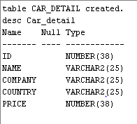

insert into Car_detail values(1,"Swift","Maruti Suzuki","India",4);

insert into Car_detail values(2,"i20","Hyuandai","Japan",6);

insert into Car_detail values(3,"nano","Tata","India",2);

insert into Car_detail values(4,"370z","Nissan","Japan",40);

insert into Car_detail values(5,"GT-R","Nissan","Japan",17);

insert into Car_detail values(6,"Fortuner","Toyota","Japan",12);

insert into Car_detail values(7,"m3","BMW","Germany",28);

insert into Car_detail values(8,"x21","BMW","Germany",20);

insert into Car_detail values(9,"Bolt","Tata","India",8);

insert into Car_detail values(10,"Wagon-R","Maruti Suzuki","India",4);

insert into Car_detail values(2,"i10","Hyuandai","Japan",4);

insert into Car_detail values(11,'Fiesta','Ford','America',4);

insert into Car_detail values(12,'Mustang','Ford','America',4);

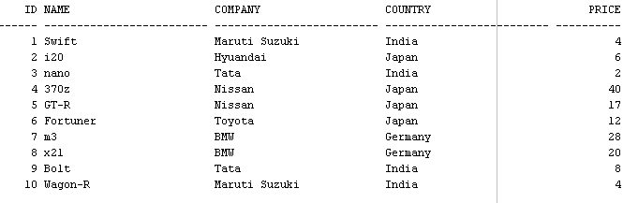

select distinct company from car_detail;

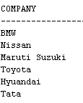

select distinct country from car_detail;



select * from car_detail

where price between 4 and 7;

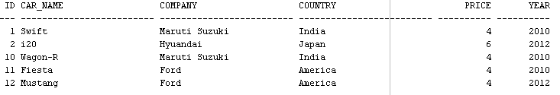

select name,company from car_detail

where price <=6 and country = 'Japan';



select name,company from car_detail

where price >20 or company='Nissan';

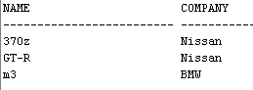

select name from car_detail

where company in ('Ford','Maruti Suzuki');

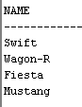

alter table car_detail

add year int;

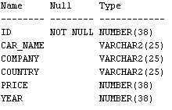

select name as Car_name from car_detail;

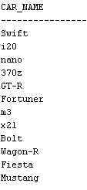

alter table car_detail

rename column name to Car_name;

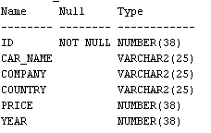

alter table car_detail

add year int;

update car_detail

set year=2012

where id=2 or id=5 or id=9 or id=12;

update car_detail

set year=2010

where year is null;

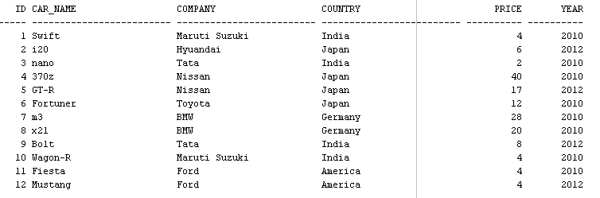

select car_name as cars_toyota from car_detail

where company = 'Toyota';



select car_name from car_detail

order by car_name asc;

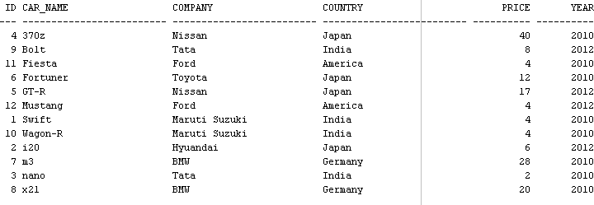

select car_name from car_detail

order by price desc;

